
MINI PROJECT REPORT
ON
“LINEAR VS CIRCULAR CONVOLUTION IN PRACTICAL AUDIO FILTERING”
Under the Course
DIGITAL SIGNAL PROCESSING
SUBMITTED BY
PRN | NAME OF STUDENT
102411063 | ARYAN KULKARNI

Academic Year 2026–2027
B.Tech Electronics and Communication Engineering (AI & ML)
Under the Guidance Of
Dr. Hrishikesh Vanjari
School of Engineering and Technology
DES Pune University, Pune
2026–2027

CERTIFICATE
This is to certify that Aryan Kulkarni, PRN 102411063, has completed and submitted the Mini Project Report under the course “Digital Signal Processing”, entitled “Linear vs Circular Convolution in Practical Audio Filtering”. This report is submitted in partial fulfilment of the requirements for the degree of Bachelor of Technology in Electronics and Communication Engineering (AI & ML) at DES Pune University, Pune, during the academic year 2026–2027.

DR. HRISHIKESH VANJARI | DR. PRACHI JOSHI
Mentor | HoS

ACKNOWLEDGMENT
I would like to express my sincere gratitude to my faculty mentor, Dr. Hrishikesh Vanjari, for his guidance, support, and encouragement throughout the completion of this Digital Signal Processing mini-project.
I would also like to thank the School of Engineering and Technology and DES Pune University, Pune, for providing the academic environment and opportunity to explore practical Digital Signal Processing concepts.
I am grateful to the developers and documentation teams of Python, NumPy, Pandas, Matplotlib, and SciPy. These tools supported the implementation of convolution algorithms, FFT-based processing, error analysis, visualisation, and execution-time measurements.
This project strengthened my understanding of discrete-time signals, impulse responses, linear and circular convolution, zero-padding, FFT computation, and numerical validation.

ABSTRACT
Convolution is a fundamental operation in Digital Signal Processing (DSP) and is widely used to describe the output of linear time-invariant systems, including digital filters. This project investigates the difference between linear convolution and circular convolution and demonstrates how zero-padding enables FFT-based convolution to reproduce the complete linear convolution result.
A discrete-time input signal containing two sinusoidal components is generated with 64 samples. It is combined with a five-coefficient finite impulse response (FIR) sequence, h[n] = [1.0, 0.5, 0.25, −0.1, 0.05]. The full linear convolution therefore contains 64 + 5 − 1 = 68 samples. A 64-point circular convolution is compared with the linear reference and exhibits wraparound error. The sequences are then zero-padded to length 68 and processed using FFT multiplication followed by the inverse FFT.
The short circular convolution has an MSE of approximately 6.708126 × 10⁻⁴, RMSE of approximately 2.590005 × 10⁻², and maximum absolute error of approximately 2.061794 × 10⁻¹. The zero-padded FFT output matches the linear reference to floating-point precision. Runtime measurements are also performed for input lengths from 64 to 4096 samples; in the recorded run, direct convolution is faster than FFT convolution for the tested short filter. The project highlights the importance of selecting a sufficient transform length and evaluating accuracy and speed using measured results.
Keywords: Digital Signal Processing, linear convolution, circular convolution, FFT, zero-padding, FIR filter, MSE, RMSE.

INDEX
CHAPTER NO. | TOPIC | PAGE NO.
1 | Introduction | 6
1.1 | Background | 6
1.2 | Need / Importance | 6
1.3 | Objectives | 6
1.4 | Scope | 6
2 | Literature Review | 7
2.1 | Relevant concepts and theories | 7
2.2 | Technologies related to the project | 7
2.3 | Summary of similar work | 7
3 | Proposed Methodology | 8
3.1 | System Overview | 8
3.2 | Architecture / Workflow Diagram | 8
3.3 | Data Collection / Input Description | 8
3.4 | Algorithms / Techniques Used | 8–9
3.5 | Tools and software used | 9
3.6 | Module-wise Implementation Plan | 9
3.7 | Validation and Testing Strategy | 9
4 | Results / Observations | 10
4.1 | Experimental / Implementation Setup | 10
4.2 | Performance Metrics | 10
4.3 | Comparison with Expected Results | 10–11
4.4 | Observations and Analysis | 11–12
4.5 | Validation and Verification | 13
5 | Future Enhancement | 14
6 | Conclusion & Recommendations | 15
7 | References / Bibliography | 16

CHAPTER 1: INTRODUCTION

1.1 Background
Digital Signal Processing deals with the representation and manipulation of signals in discrete time. A signal may represent audio, vibration, sensor measurements, images, or other data. Digital filters are systems that modify a signal to achieve a desired response, such as smoothing, attenuation, or frequency selection.
For a discrete-time linear time-invariant (LTI) system, the output can be calculated by convolving the input sequence with the system impulse response. Convolution can be computed directly in the time domain or through frequency-domain methods based on the Discrete Fourier Transform (DFT) and Fast Fourier Transform (FFT).
Linear convolution gives the complete output of finite-length sequences. Circular convolution assumes periodic sequences and is naturally associated with the DFT. If circular convolution is performed with a length that is too short, the end of the output wraps around and affects earlier samples. Zero-padding can prevent this overlap when the transform length is selected correctly.

1.2 Need / Importance
Understanding the difference between linear and circular convolution is important because FFT-based processing is common in practical DSP. Using an insufficient transform length can produce an incorrect output even when the FFT and inverse FFT operations are implemented correctly. This project makes the issue visible by comparing outputs, measuring numerical errors, and testing several FFT lengths.

1.3 Objectives
- Generate a discrete-time signal containing two sinusoidal components.
- Define a finite-length impulse response to represent a simple digital filter.
- Calculate full linear convolution and 64-point circular convolution.
- Apply zero-padding and FFT-based convolution using a sufficient transform length.
- Compare outputs using MSE, RMSE, and maximum absolute error.
- Investigate how FFT length affects the convolution result.
- Measure direct and FFT-based convolution execution times for several input lengths.
- Visualise the signals, convolution outputs, errors, and runtime observations.

1.4 Scope
The project is a numerical demonstration of convolution using Python. It uses a synthetic signal rather than a recorded audio file, and a short five-coefficient impulse response. It focuses on correctness, wraparound error, zero-padding, and a basic runtime comparison. It does not claim to implement a complete audio application or to evaluate perceptual audio quality.

CHAPTER 2: LITERATURE REVIEW

2.1 Relevant Concepts and Theories

Discrete-time signals
A discrete-time signal is represented as a sequence x[n], where n is an integer sample index. In this experiment, n ranges from 0 to 63. The input is formed by adding two sinusoidal components: x[n] = sin(2π·0.08n) + 0.5 sin(2π·0.22n). The frequencies are expressed in cycles per sample.

Impulse response and convolution
The impulse response h[n] describes the response of an LTI system to a unit impulse. For the chosen finite sequence, h[n] = [1.0, 0.5, 0.25, −0.1, 0.05]. The full linear convolution is defined by y[n] = Σ x[k]h[n−k]. For finite sequences with lengths Nₓ and Nₕ, the output length is Nₓ + Nₕ − 1.

Linear versus circular convolution
Linear convolution produces the full non-periodic finite-sequence result. N-point circular convolution operates on N-periodic representations of the sequences. When N is shorter than Nₓ + Nₕ − 1, the linear-convolution samples overlap modulo N, producing time-domain aliasing or wraparound.

Convolution theorem and zero-padding
The convolution theorem states that convolution in the time domain corresponds to multiplication in the frequency domain. In this implementation, the FFT of each zero-padded sequence is multiplied element by element, and the inverse FFT returns the result to the time domain. To obtain full linear convolution, the transform length must satisfy N ≥ Nₓ + Nₕ − 1.

2.2 Technologies Related to the Project
Python is used as the programming language. NumPy provides array operations and FFT/IFFT routines. Pandas loads CSV data and creates result tables. Matplotlib generates graphs. SciPy provides direct convolution and FFT-based convolution functions for the runtime comparison. The notebook is designed to run in a Jupyter/Google Colab environment.

2.3 Summary of Similar Work or Case Studies
Standard DSP textbooks explain convolution as the input-output relation for LTI systems and describe the DFT relationship to circular convolution. Cooley and Tukey’s classic FFT paper established an efficient approach to computing Fourier transforms. Modern numerical libraries implement these operations, allowing the same principles to be tested experimentally. This project follows these established concepts in a small, reproducible numerical experiment; it is not a reproduction of a specific external case study.

CHAPTER 3: PROPOSED METHODOLOGY

3.1 System Overview
The system accepts an input signal and a filter impulse response. It calculates full linear convolution as a reference, calculates circular convolution with N = 64 to demonstrate wraparound, and then calculates FFT-based convolution after zero-padding to N = 68. Numerical error metrics compare the results. A separate experiment measures execution time for direct and FFT-based convolution with a 31-sample sequence.

3.2 Architecture / Workflow Diagram
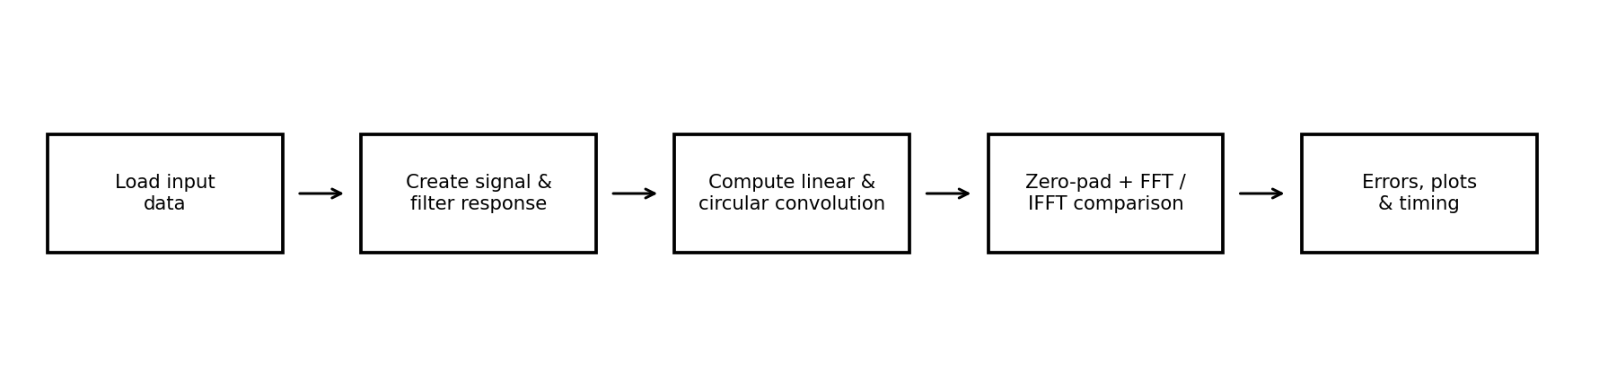
Figure 3.1: Workflow of the convolution comparison project.

3.3 Data Collection / Input Description
The primary experiment uses a mathematically generated signal and a fixed impulse response. The notebook also supports storing the two sequences in separate CSV files for reproducibility. input_signal.csv contains 64 sample indices and signal values. impulse_response.csv contains five sample indices and the five filter coefficients.
Parameter | Value / Description
Input signal | x[n] = sin(2π·0.08n) + 0.5 sin(2π·0.22n)
Input length | 64 samples
Impulse response | [1.0, 0.5, 0.25, −0.1, 0.05]
Impulse response length | 5 coefficients
Full linear output length | 64 + 5 − 1 = 68 samples
Short circular length | N = 64
Padded FFT length | N = 68

The supplied notebook generates x[n] and h[n] directly in its signal-generation cell. The CSV files are also provided as input-data artifacts. During a run, use one consistent source for the arrays so that the saved inputs and reported outputs correspond.

3.4 Algorithms / Techniques Used

A. Direct linear convolution
The full convolution operation returns all output samples. Its length is 68 for the chosen input and filter. Implementation: y_linear = np.convolve(x, h, mode="full").

B. N-point circular convolution
The sequences are transformed with N-point FFTs, multiplied element by element, and transformed back using the inverse FFT. With N = 64, the result has 64 samples and exhibits wraparound relative to the 68-sample linear reference. Conceptually: y_circular = IFFT(FFT(x, N) × FFT(h, N)).

C. Zero-padded FFT convolution
The minimum sufficient transform length is N = 68. The FFT and inverse FFT operations are applied at this length. The resulting 68 output samples match direct linear convolution within floating-point precision.

D. Error and timing analysis
The error is calculated as the reference output minus the estimated output. MSE, RMSE, and maximum absolute error summarise the difference. Timing is measured with repeated calls to direct convolution and SciPy fftconvolve after a warm-up call.

3.5 Tools, Software, or Equipment Used
Tool / Library | Purpose
Python | Implementation language
NumPy | Arrays, FFT, inverse FFT, and numerical operations
Pandas | CSV loading and result tables
Matplotlib | Signal, output, error, and timing plots
SciPy | Direct and FFT-based convolution timing
Jupyter / Google Colab | Notebook execution environment

No physical equipment or external audio recording is required for the current experiment.

3.6 Module-wise Implementation Plan
Module | Implementation / Output
1. Setup | Import required Python libraries.
2. Signal generation | Create the 64-sample sinusoidal input and five-coefficient impulse response; plot both.
3. Convolution | Compute full linear, short circular, and zero-padded convolution outputs.
4. Visual comparison | Plot linear versus circular output and linear versus padded FFT output.
5. Error analysis | Calculate MSE, RMSE, and maximum absolute error; save comparison CSV.
6. FFT-length experiment | Test N = 64, 68, 79, 96, and 128; plot RMSE versus FFT length.
7. Runtime experiment | Compare direct and FFT convolution for input lengths 64, 256, 1024, and 4096.
8. Export | Save result tables and plots for inclusion in the report.

3.7 Validation and Testing Strategy
The implementation is validated by checking the expected linear output length of 68; verifying that the short circular result has 64 samples; comparing the 64-point circular result with the first 64 samples of the linear reference; comparing the zero-padded result with the full linear reference; testing multiple FFT lengths; and inspecting error metrics and plots. The expected result is that N = 64 produces measurable wraparound error, while N ≥ 68 matches the linear reference within numerical precision.

CHAPTER 4: RESULTS / OBSERVATIONS

4.1 Experimental / Implementation Setup
The experiment was implemented in a Python notebook using NumPy, Pandas, Matplotlib, and SciPy. The main signal has 64 samples and the impulse response has five coefficients. Full linear convolution is the reference. The short circular convolution uses N = 64, while the zero-padded FFT experiment uses N = 68. FFT-length tests are conducted at N = 64, 68, 79, 96, and 128.

Input signal and impulse response
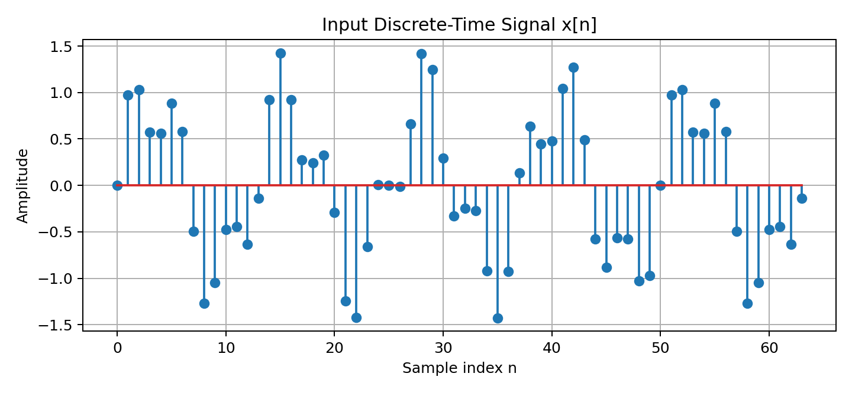
Figure 4.1: Generated 64-sample input signal x[n].
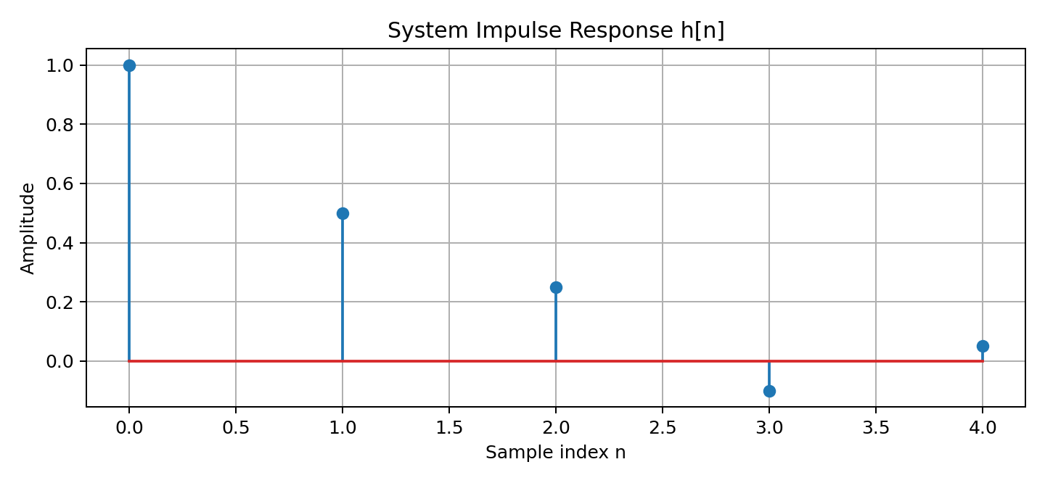
Figure 4.2: Five-coefficient impulse response h[n].

4.2 Performance Metrics
The metrics compare an estimated output with the reference linear-convolution output. The short circular result is compared over the common 64 samples; the zero-padded result is compared over all 68 samples.
Metric | Definition | Interpretation
MSE | Mean of squared sample errors | Penalises larger deviations more strongly.
RMSE | Square root of MSE | Expresses error in the signal amplitude units.
Maximum absolute error | Largest absolute sample error | Shows the worst single-sample deviation.

4.3 Comparison with Expected Results
Method | MSE | RMSE | Maximum absolute error
Direct linear convolution | 0.000000e+00 | 0.000000e+00 | 0.000000e+00
Circular convolution, N=64 | 6.708126e-04 | 2.590005e-02 | 2.061794e-01
FFT convolution, N=68 | 7.226144e-32 | 2.688149e-16 | 6.661338e-16

Direct linear convolution is the reference, so comparing it with itself gives zero error. Circular convolution at N = 64 has non-zero error. With N = 68, the zero-padded FFT output agrees with the reference to floating-point precision; very small numerical differences may appear before rounding.

Linear versus circular convolution
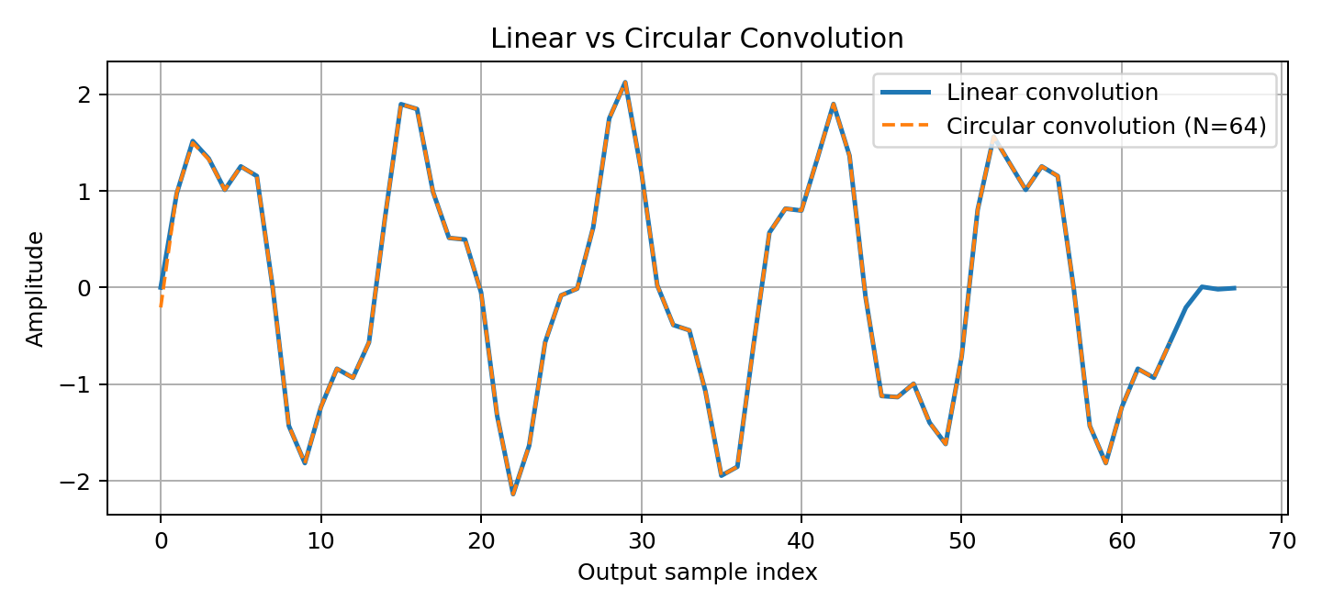
Figure 4.3: Full linear convolution compared with 64-point circular convolution.

Zero-padded FFT comparison
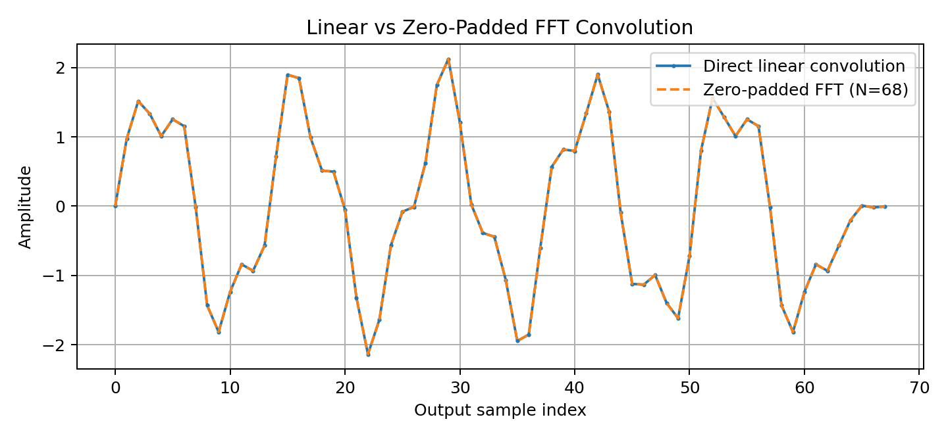
Figure 4.4: Linear convolution compared with FFT convolution using N = 68.

4.4 Observations and Analysis
The 64-point circular convolution does not contain the full 68-sample linear output. The end of the linear-convolution result wraps around under the modulo-64 circular operation, causing differences in the output and an incomplete output length. This is visible in the comparison plot and reflected by non-zero error metrics.
When N is increased to 68, enough positions are available to represent the full linear convolution. The zero-padded FFT result overlays the linear reference. Larger tested lengths—79, 96, and 128—also produce matching results within numerical precision. Increasing N beyond the minimum is valid, although it may add computation without improving the mathematical output.

FFT length experiment
FFT length N | Required length | Padding sufficient? | RMSE | Max absolute error
64 | 68 | No | 2.590e-02 | 2.062e-01
68 | 68 | Yes | 2.688e-16 | 6.661e-16
79 | 68 | Yes | 2.688e-16 | 6.661e-16
96 | 68 | Yes | 2.688e-16 | 6.661e-16
128 | 68 | Yes | 2.688e-16 | 6.661e-16

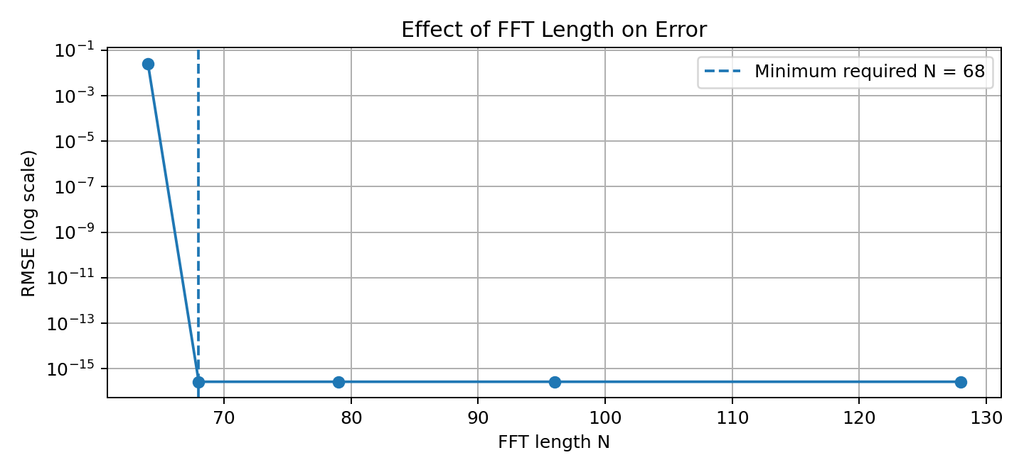
Figure 4.5: RMSE against FFT length; marker indicates minimum required length.

Runtime comparison
Runtime measurements are environment-dependent and should be interpreted as observations from this particular run rather than universal performance guarantees.
Input length | Filter length | Direct time (ms) | FFT time (ms)
64 | 31 | 0.02306 | 0.16745
256 | 31 | 0.03924 | 0.12414
1024 | 31 | 0.02909 | 0.08543
4096 | 31 | 0.09216 | 0.14390

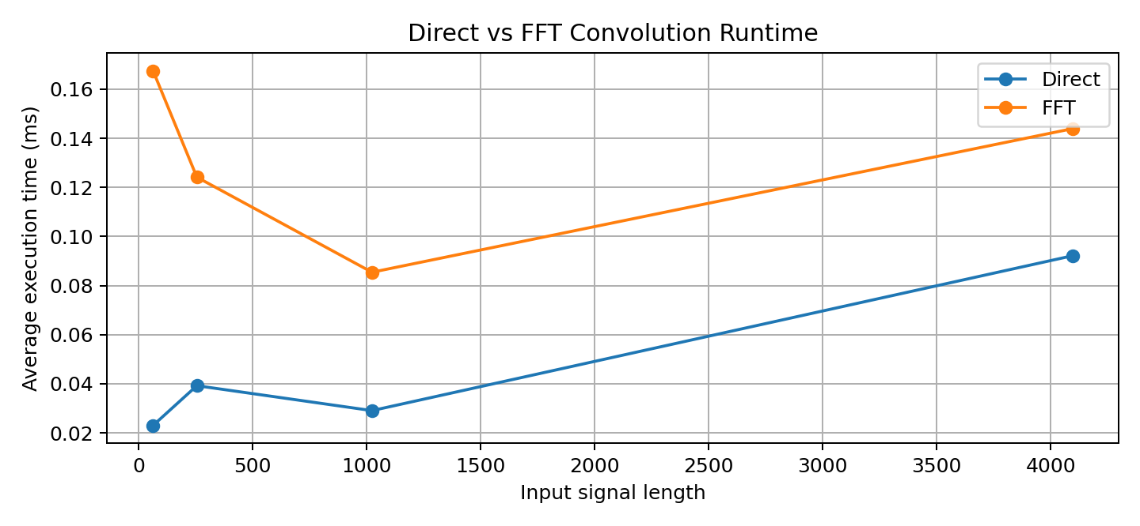
Figure 4.6: Measured direct and FFT convolution runtime for different input lengths.
In the recorded run, direct convolution was faster for all four tested input lengths. The filter used in this timing experiment has 31 samples, and the timing procedure uses warm-up calls and repeated measurements. FFT convolution has extra transform overhead; its asymptotic advantages may become more evident for longer signals or longer filters. A new run on different hardware or software may produce different timings.

4.5 Validation and Verification with Summary of Findings
- The output length check passed: 64 + 5 − 1 = 68 samples for full linear convolution.
- The short circular convolution output has 64 samples, confirming that it does not contain the full linear output.
- The circular convolution error is non-zero: MSE ≈ 6.708126 × 10⁻⁴, RMSE ≈ 2.590005 × 10⁻², and maximum absolute error ≈ 2.061794 × 10⁻¹.
- Zero-padding to N = 68 produces an FFT result matching the linear reference within floating-point precision.
- All tested lengths at or above 68 (68, 79, 96, 128) provide the expected full linear result.
- The runtime experiment found direct convolution faster for the tested sequence sizes in this specific environment.

CHAPTER 5: FUTURE ENHANCEMENT
- Use a real recorded audio clip and compare the input and filtered output by listening and plotting waveforms.
- Design additional FIR and IIR filters, such as low-pass, high-pass, and band-pass filters, and study their frequency responses.
- Plot magnitude and phase spectra before and after filtering to show the frequency-domain effect of the filter.
- Compare direct and FFT convolution across longer input signals and longer impulse responses to identify when FFT processing becomes beneficial.
- Repeat timing tests multiple times on different hardware and report average, median, and variability rather than relying on one timing run.
- Explore overlap-add and overlap-save methods for long signals that cannot be processed efficiently in one large FFT.
- Build a simple interface that lets a user choose the signal, filter coefficients, and FFT length and view the resulting output and error metrics.
- Add unit tests for output length, numerical tolerances, and edge cases such as one-sample sequences.
These enhancements would make the demonstration more representative of practical audio-processing applications while retaining the current focus on convolution correctness.

CHAPTER 6: CONCLUSION & RECOMMENDATIONS
This mini-project demonstrates the difference between linear convolution and circular convolution using a 64-sample discrete-time signal and a five-coefficient impulse response. The expected full linear output length is 68 samples. When circular convolution is performed with N = 64, the result exhibits wraparound error because the transform length is insufficient.
The project then applies zero-padding and FFT-based convolution with N = 68. The resulting output matches the direct linear convolution reference within floating-point precision. The error metrics quantify the difference: the short circular convolution has measurable error, while the padded FFT result has effectively zero error at practical numerical precision.
The runtime experiment shows that direct convolution was faster than FFT convolution for the tested sequence sizes and filter length in the recorded run. This highlights that theoretical complexity alone does not determine observed runtime; transform overhead, signal length, filter length, and implementation all matter.
It is recommended to choose an FFT length of at least Nₓ + Nₕ − 1 when the goal is to obtain full linear convolution through FFT multiplication. Output lengths, error metrics, and plots should be checked as part of validation. Runtime conclusions should be based on repeated measurements and should clearly state the tested conditions.
Overall, the project achieves its objectives by illustrating circular wraparound, demonstrating the role of zero-padding, and validating FFT-based convolution against a direct reference.

CHAPTER 7: REFERENCES / BIBLIOGRAPHY
[1] A. V. Oppenheim and R. W. Schafer, Discrete-Time Signal Processing, 3rd ed. Pearson, 2010.
[2] J. W. Cooley and J. W. Tukey, “An algorithm for the machine calculation of complex Fourier series,” Mathematics of Computation, vol. 19, no. 90, pp. 297–301, 1965. doi: 10.1090/S0025-5718-1965-0178586-1.
[3] NumPy Developers, “numpy.fft.fft,” NumPy documentation. https://numpy.org/doc/stable/reference/generated/numpy.fft.fft.html
[4] NumPy Developers, “numpy.fft.ifft,” NumPy documentation. https://numpy.org/doc/stable/reference/generated/numpy.fft.ifft.html
[5] SciPy Developers, “scipy.signal.convolve,” SciPy documentation. https://docs.scipy.org/doc/scipy/reference/generated/scipy.signal.convolve.html
[6] SciPy Developers, “scipy.signal.fftconvolve,” SciPy documentation. https://docs.scipy.org/doc/scipy/reference/generated/scipy.signal.fftconvolve.html
[7] Pandas Development Team, “pandas.read_csv,” pandas documentation. https://pandas.pydata.org/docs/reference/api/pandas.read_csv.html
[8] Matplotlib Development Team, Matplotlib documentation. https://matplotlib.org/stable/

